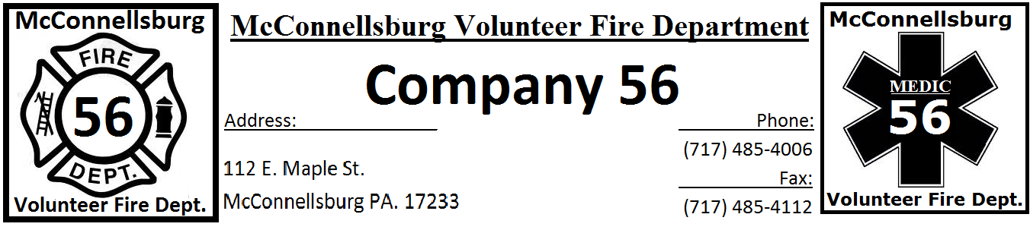

- EMT Requirements:
  - Pennsylvania EMT Or NREMT (Will assist with reciprocity)
  - Valid PA Driver’s License
  - American Heart Assoc. CPR
  - EVOC or EVDT within 5 years
  - NIMS 100, 200, 700, 800
  - Act 34, Act 114, and Act 168 Clearances

- Paramedic Requirements:
  - Pennsylvania Paramedic Or NREMT (Will assist with reciprocity)
  - Valid PA Driver’s License
  - American Heart Assoc. CPR
  - Current Medical Command
  - Current ACLS, PALS, ITLS/PHTLS, CPR
  - NIMS 100, 200, 700, 800
  - Act 34, Act 114, and Act 168 Clearances

Job Summary:
- McConnellsburg EMS, a division of the McConnellsburg Volunteer Fire Department, is a progressive, fast paced EMS service in Central Fulton County that responds to 1500 Emergency and Non-Emergency calls which includes Inter-Facility Transports. Our unique setting offers a variety of call types, educational opportunities, and much more. We are looking for motivated individuals to join our team, and to help us provide the highest level of care possible to those in need. FF1 or higher is preferred but not required.
- Updated Pay Rate, Paid Vacation (Up to 2 weeks)
- Benefits and pay will be discussed upon interview

- If Interested Applicants can submit a resume to the McConnellsburg Volunteer Fire Company at PO BOX 724 McConnellsburg, Pa 17233 or you may Contact the Fire Chief Pete Lynch at 717-860-3733 Email petelynch@pa.net or the EMS Captain Chip Keebaugh at 717-331-7824 Email ckeebaugh@mvfc56.org

