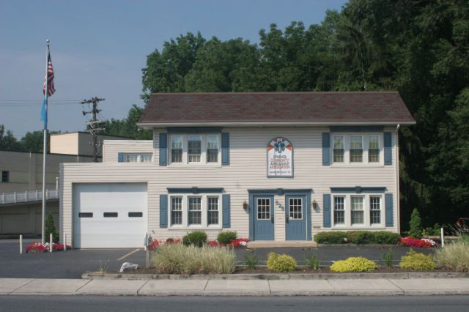

Ephrata Community Ambulance Association
is currently accepting resumes for

Full-time – (3 extended days with 4 days off per week)

Full -time – Monday-Friday, 10 hour days – 50 hours a week

Full-time – Sunday -Thursday nights, 2200-0800 hours – 50 hours a week

Part-time

Emergency Medical Technicians

Experience Preferred.
Part-time hours available are evening and weekend hours.
SEND RESUME TO:
EPHRATA COMMUNITY AMBULANCE ASSOCIATION
528 WEST MAIN STREET, EPHRATA, PA 17522

ATTN: EMS MANAGER
E.O.E.
Or email to emsmgr@EphrataAmbulance.org

