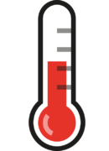
EMS Provider Self-Screening Checklist
For Use Prior to Shift

EMS providers should take their temperature twice daily: prior to the start of their shift and repeat every 12-hours.

EMS providers should monitor daily even if off-duty.

If a fever or upper respiratory symptoms are present, the EMS agency should notify their EMS agency as soon as possible.

EMS Provider Name:

Date | Time | Temperature |  | Date | Time | Temperature

